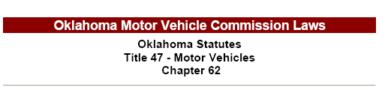

(See Oklahoma Motor Vehicle Commission Laws for full text.)

